**Riphah International University Gulberg Green**



**Name: SALEHA RAFIQUE  
Sap id: 49316  
Course: Operating System lab**

**Lab: 05**

**Task 1:**

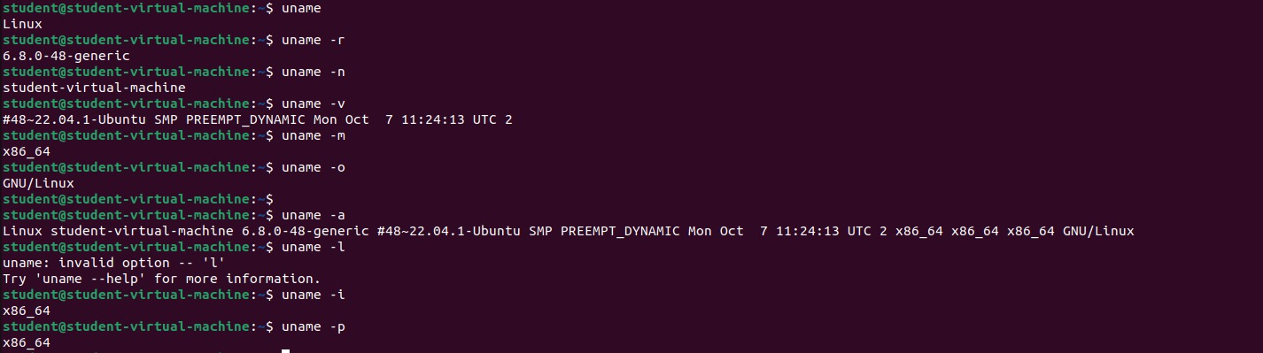

• **-r**: Displays the kernel release version.

• **-m**: Shows the machine hardware name (architecture).

• **-p**: Displays the processor type (if available).

• **-I**: Shows the hardware platform (e.g., x86_64).

• **-o**: Displays the operating system name.

• **-a**: Prints all available system information (kernel, machine, OS, etc.).

• **-v**: Displays the kernel version.

• **-n**: Displays the network node hostname.

**Task 2:**

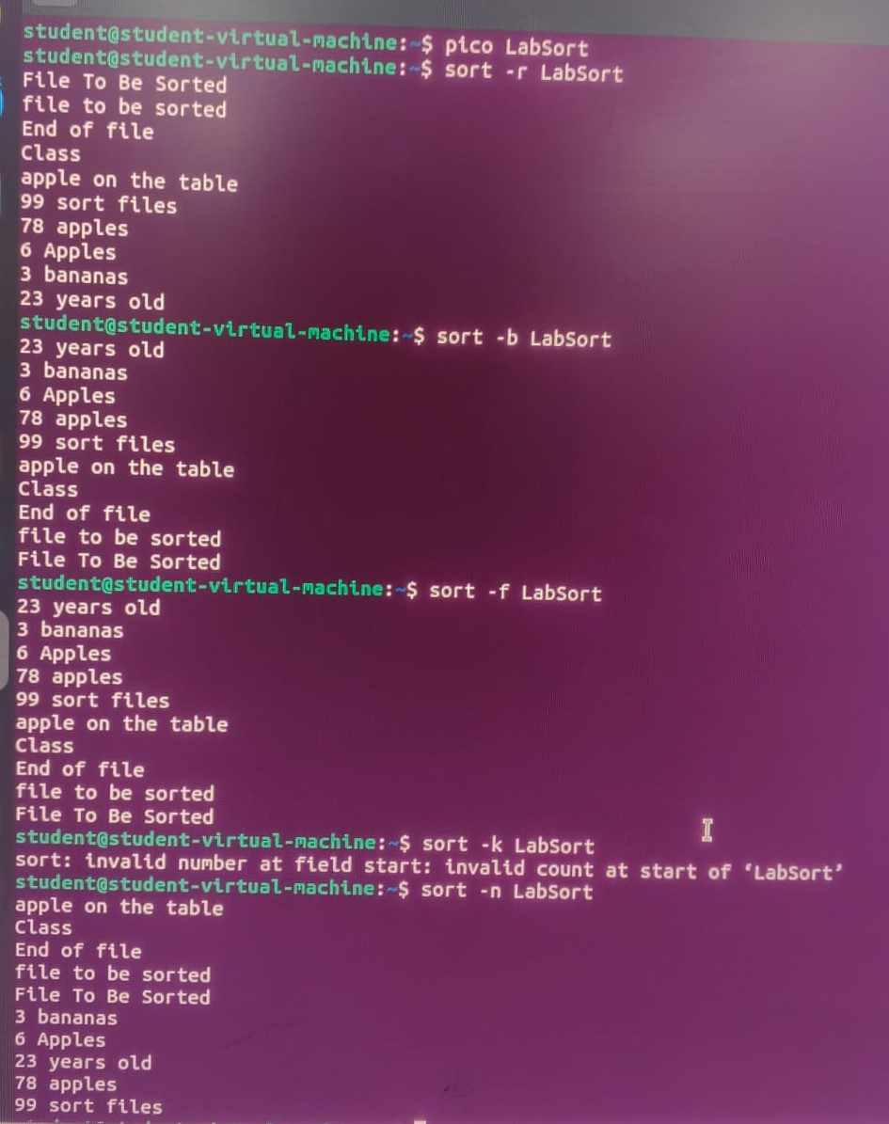

**Task 3:**

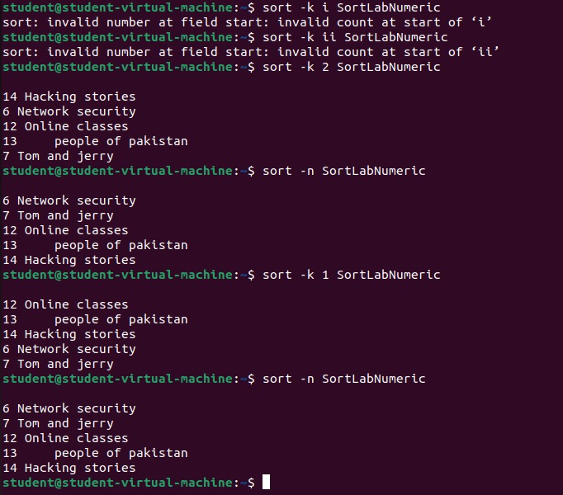

**Task 4:**

The cd command is used in Linux to navigate between directories. While cd itself doesn't have many options, there are some variations that allow for flexible navigation.

• cd changes the working directory.

• cd <directory> navigates to a specific directory.

• cd - returns you to the previous directory.

• cd ~ or cd brings you to the home directory.

• cd.. moves up one directory level.